**Deploy Static Website on AWS**



Sherif Hassan Magdy

12/11/2022

* **S3 bucket creation and upload the static content into it: -**
  + The S3 bucket created with name “[my-961226122142-bucket](https://s3.console.aws.amazon.com/s3/buckets/my-961226122142-bucket?region=us-east-1)”

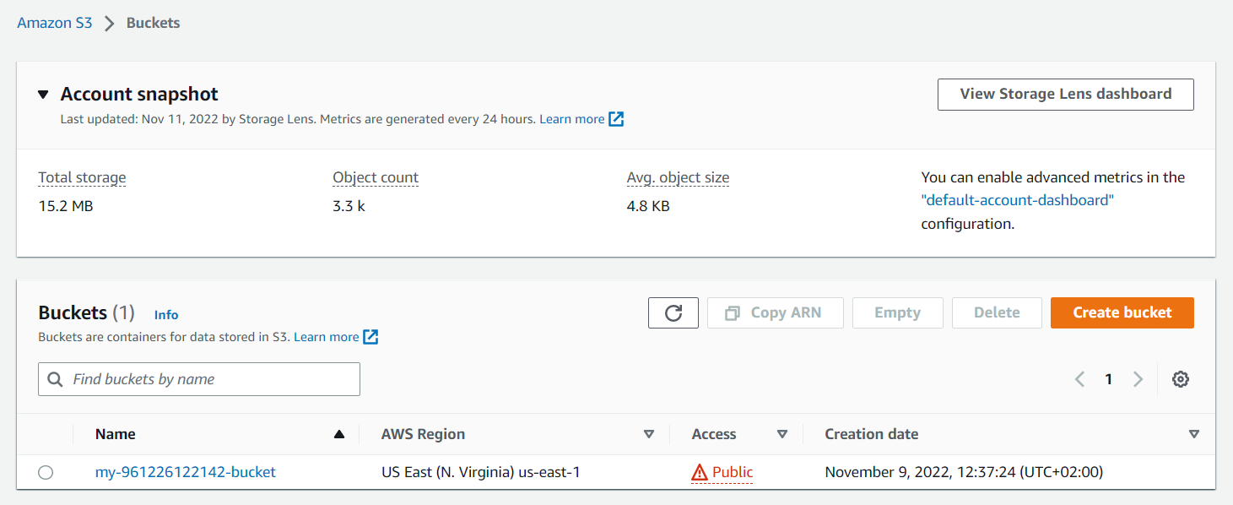

* + Upload the website content into created bucket

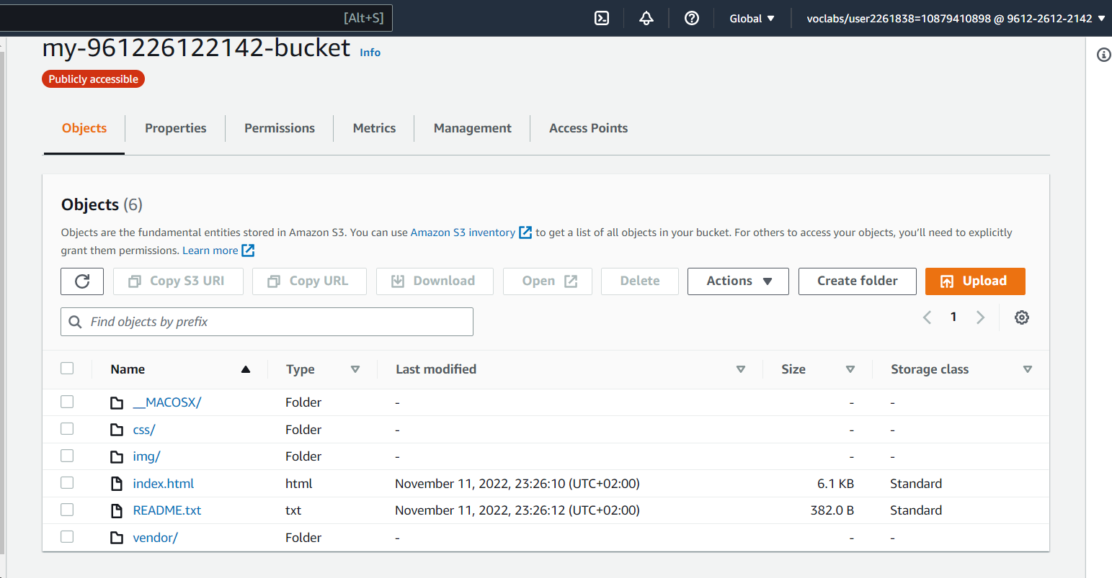

* + The S3 bucket configured for hosting the static content

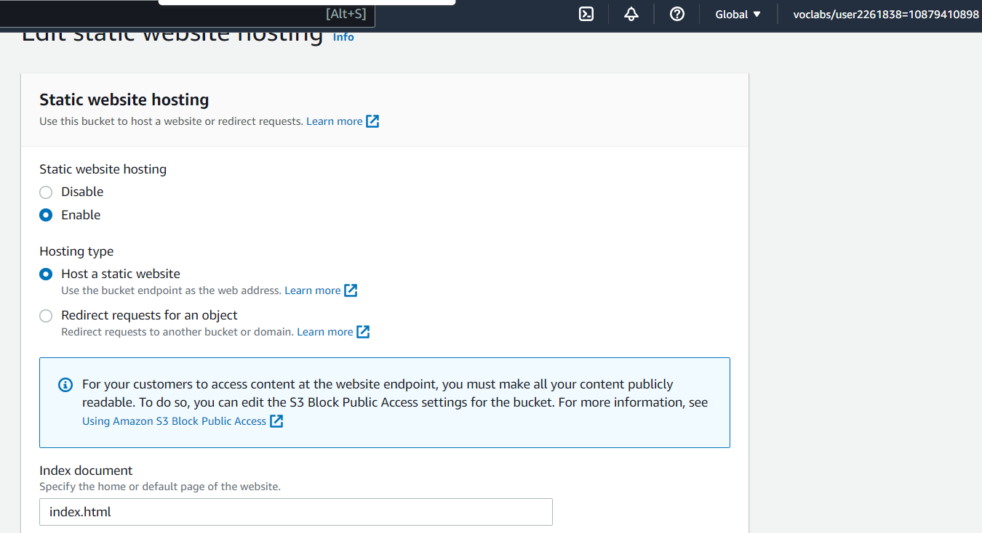

* + The S3 bucket has an IAM bucket policy that makes the bucket contents publicly accessible

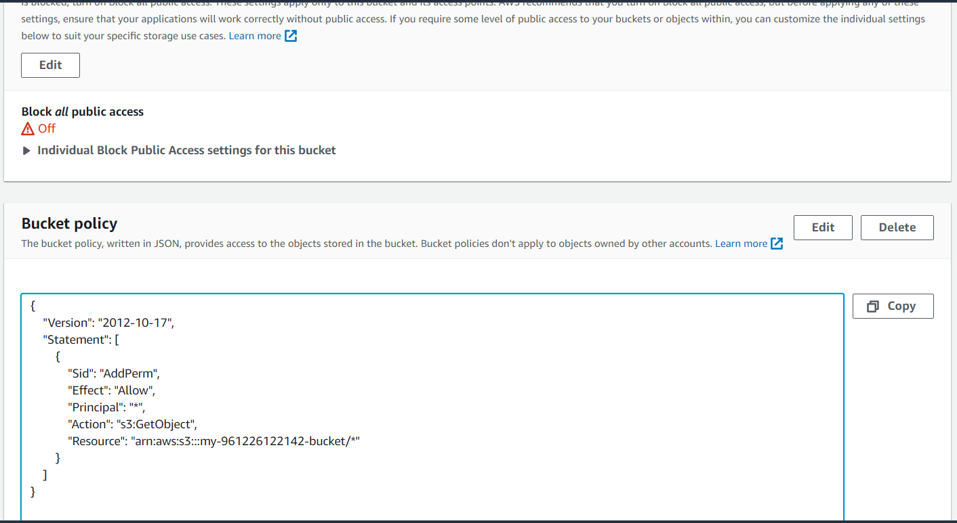

* **Website Distribution through Cloud-Front service**
  + The distribution created with domain name “d2wlhmi1fcd2js”

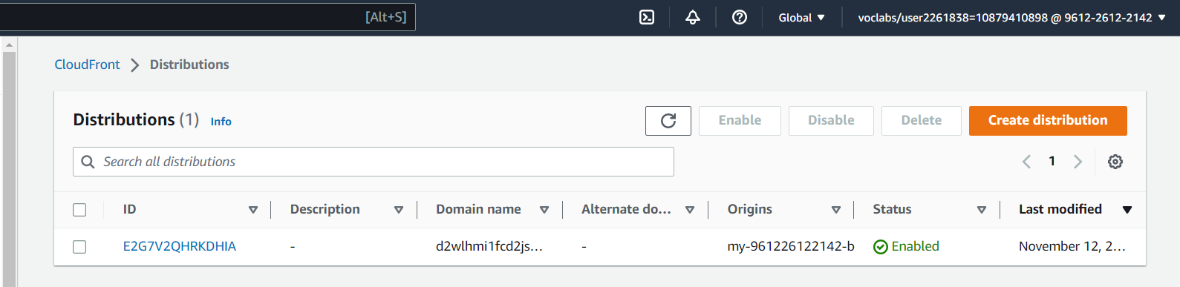

* **Access the published interfaces from the web browser**
  + Access the website through the S3
    - <URL:-> <http://my-961226122142-bucket.s3-website-us-east-1.amazonaws.com/>

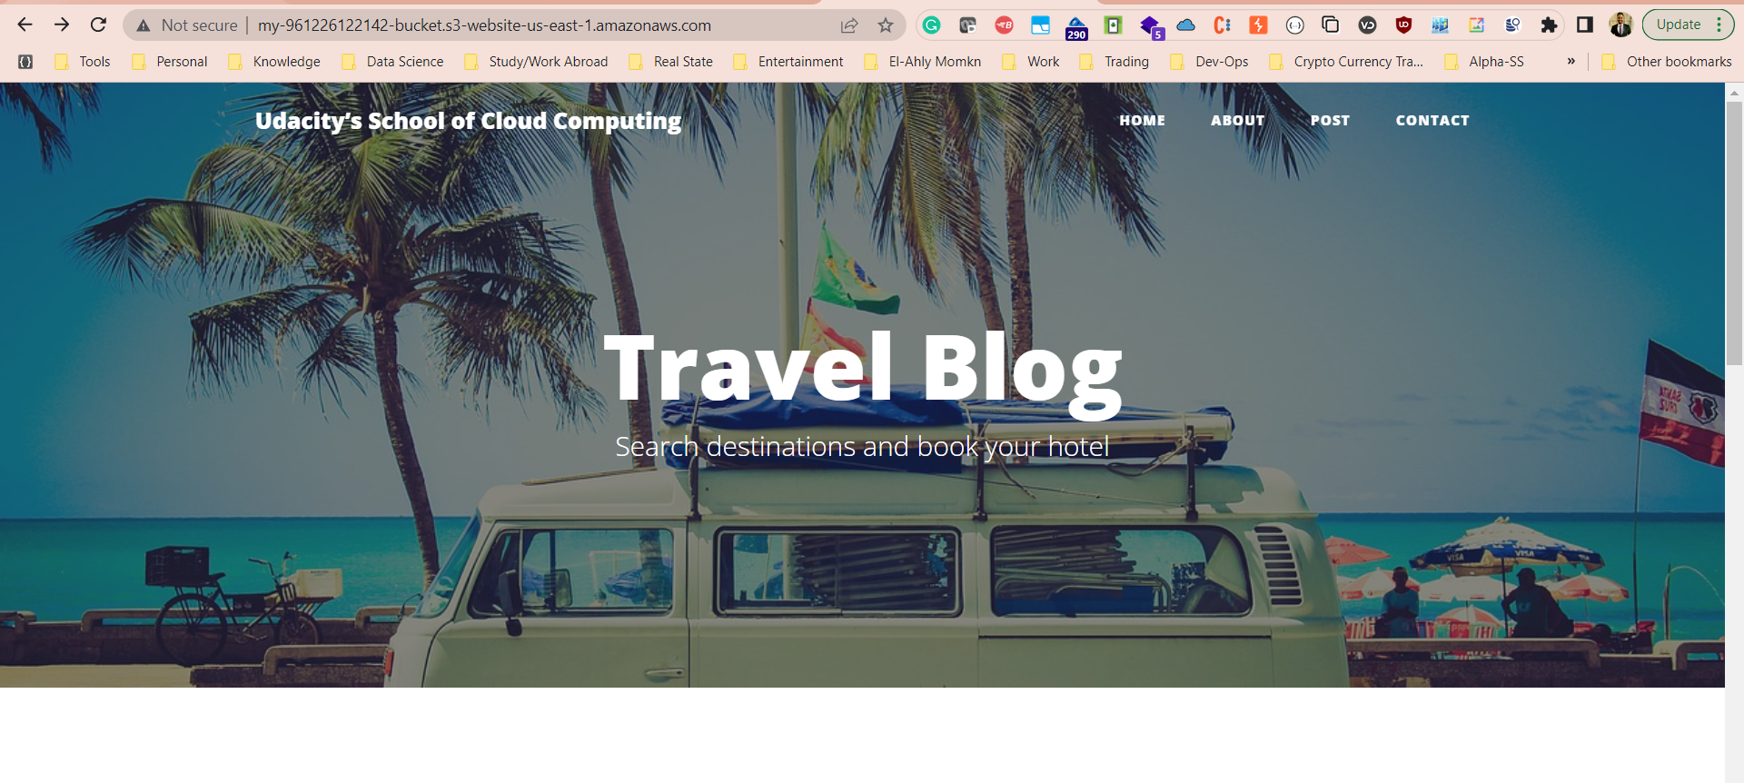

* + Access the website through the S3 bucket object
    - URL:- <http://my-961226122142-bucket.s3-website-us-east-1.amazonaws.com/index.html>

* + Access the website through the Cloud-Front created domain
    - <URL:-> <https://d2wlhmi1fcd2js.cloudfront.net/index.html>

